TN SKILL PROJECT | REQUIREMENT ANALYSIS PHASE
Auto Ticket Classification using Flow Designer
Data Flow Diagram (DFD) & Data Requirements

1. OBJECTIVE OF THE DATA FLOW DIAGRAM
A Data Flow Diagram shows how information moves through the Auto Ticket Classification system: where a ticket comes from, how Flow Designer processes it, where the data is stored and who receives the result. It turns the requirements of the earlier phases into a clear model of inputs, processes and outputs that the design and build phases can follow.

2. DFD NOTATION USED
DFD Element | Symbol | Used for
External Entity | Shaded rectangle | People or groups outside the system that send or receive data (End User, Resolver Groups).
Process | Circle | A step that transforms data (Parse Text, Apply Mapping Rules).
Data Store | Open-ended box (D1–D4) | Tables where data is held (Incident Table, Rule Table).
Data Flow | Arrow with label | Movement of data between entities, processes and stores.

3. LEVEL 0 – CONTEXT DIAGRAM
The whole solution is one process that exchanges data with four external entities. The End User raises tickets, the Tier-1 Agent handles only the unmatched exceptions, Resolver Groups receive routed tickets, and the IT Manager receives reports and maintains rules.
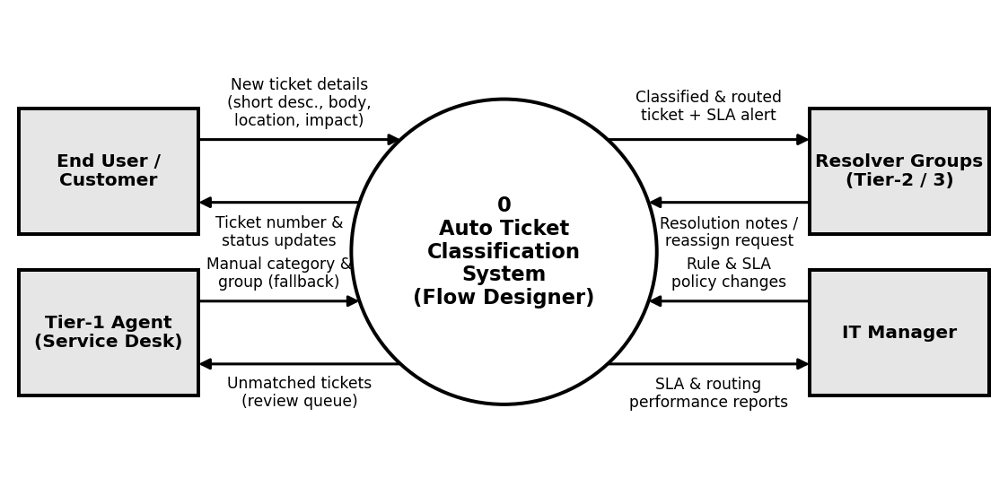
Figure 1: Level 0 DFD – Auto Ticket Classification System

4. LEVEL 1 – DETAILED DATA FLOW
Level 1 breaks the system into five processes that run in sequence inside Flow Designer, the moment a new Incident or Request is created.
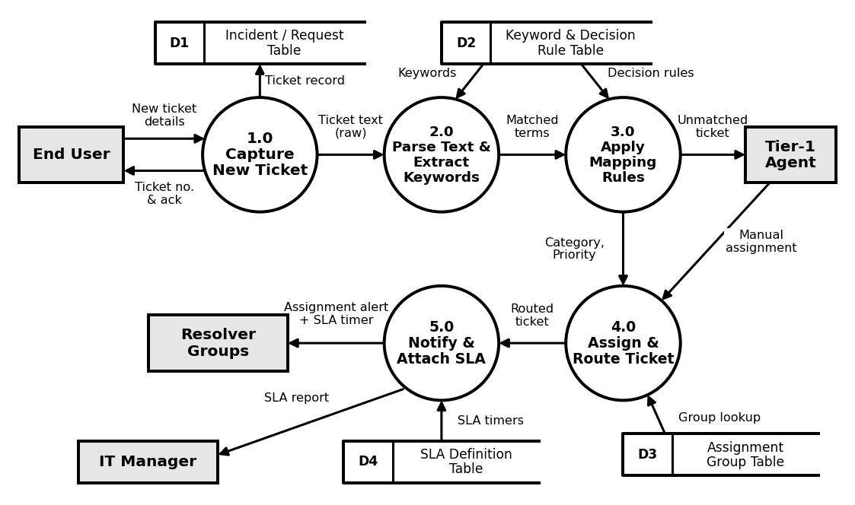
Figure 2: Level 1 DFD – Flow Designer classification and routing

5. PROCESS DESCRIPTION
ID | Process | Input | Output
1.0 | Capture New Ticket | New Incident/Request from portal or email | Ticket record saved in D1; acknowledgement to user
2.0 | Parse Text & Extract Keywords | Short description, body text, location, impact; keyword list from D2 | Matched terms (e.g. VPN, Password Reset, Hardware Failure)
3.0 | Apply Mapping Rules | Matched terms; decision rules from D2 | Category, Subcategory, Urgency, Priority; unmatched tickets to Tier-1
4.0 | Assign & Route Ticket | Classified ticket; group details from D3; manual assignment for fallback | Ticket assigned to Network, Security, Identity or other group
5.0 | Notify & Attach SLA | Routed ticket; SLA rules from D4 | Alert to resolver group, SLA timer, SLA report to manager

6. DATA STORES
ID | Data Store | Key data held | Used by
D1 | Incident / Request Table | Ticket number, short description, description, category, priority, assignment group, state | 1.0 (write), 4.0 (update)
D2 | Keyword & Decision Rule Table | Keywords, conditions, category and priority mappings | 2.0, 3.0 (read)
D3 | Assignment Group Table | Group names (Network, Security, Identity Management), members, queues | 4.0 (read)
D4 | SLA Definition Table | SLA type, response and resolution targets, timers by priority | 5.0 (read)

7. DATA FLOW DICTIONARY
Data Flow | Content | From → To
New ticket details | Short description, body text, location, service impact | End User → 1.0
Ticket text (raw) | Unstructured description saved with the ticket | 1.0 → 2.0
Matched terms | Keywords found in the text with match confidence | 2.0 → 3.0
Category, Priority | Category, Subcategory, Urgency, Priority values | 3.0 → 4.0
Unmatched ticket | Ticket with no rule match, sent to default review queue | 3.0 → Tier-1 Agent
Assignment alert + SLA timer | Group, ticket number, priority, SLA due time | 5.0 → Resolver Groups
SLA report | Response times, breaches, routing accuracy | 5.0 → IT Manager

8. DATA HANDLING RULES
- Trigger: every new Incident or Request starts the flow automatically, with no manual step.
- Fallback: a ticket with no matching keyword goes to the default review queue for a Tier-1 Agent instead of staying unassigned.
- Consistency: the same description always gives the same category and priority because rules are read from D2.
- Traceability: each classification and routing decision is recorded against the ticket in D1 for audit.
- Performance: classification and routing must finish within 10 seconds of ticket creation.

9. CONCLUSION
The DFD shows that the manual triage step is replaced by five automated processes that read from four data stores. Data now moves from ticket creation to the correct resolver group without waiting in a queue, which supports the goals of faster first response, higher routing accuracy and fewer SLA breaches.

